**Project Design Phase-I**

**Solution Architecture**

|  |  |
| --- | --- |
| **Date** | **03 November 2023** |
| **Github name** | **https://github.com/Sowmiyaa-Prakasam/NAAN-MUDHALVAN** |
| **Project Name** | BUILD AN EVENT MANAGEMENT SYSTEM |

**Solution Architecture:**

Solution architecture is a complex process – with many sub-processes – that bridges the gap between business problems and technology solutions. Its goals are to:

* Find the best tech solution to solve existing business problems.
* Describe the structure, characteristics, behaviour, and other aspects of the software to project stakeholders.
* Define features, development phases, and solution requirements.
* Provide specifications according to which the solution is defined, managed, and delivered.

**Example - Solution Architecture Diagram:**

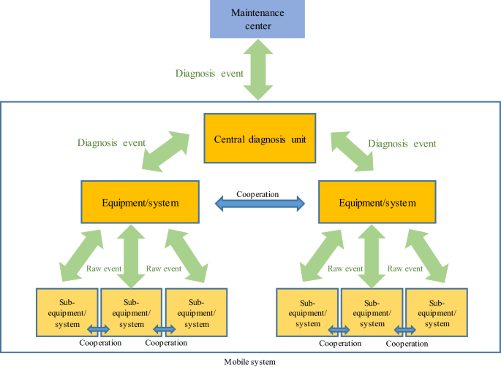

*Figure 1: Complete System Architecture for Recruting assitance for HR managers*

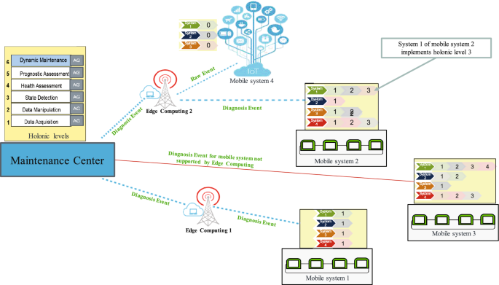

*Figure 2: Workflow diagram*